Full Stack Development with MERN Project Documentation format

1. Introduction
- Project Title: BookStore-Online Book Management System
- Team Members: Pothunuri Nandhini(Sole Developer)

2. Project Overview
- Purpose: The SmartBridge Bookstore is a full-stack web application developed using the MERN stack. The primary objective of this project is to provide an online platform where users can browse, search, and purchase books easily. The application also provides an admin panel to manage books, categories, customers, and orders efficiently.

- Features:
- User Registration and Login
- Secure Authentication using JWT
- Browse Available Books
- Search Books by Title, Author, or Category
- Add Books to Shopping Cart
- Place Orders
- Admin Dashboard
- Add, Update, and Delete Books
- Responsive User Interface
- MongoDB Database Integration

3. Architecture
- Frontend:
The frontend is developed using React.js, providing a responsive and interactive user interface. React Router is used for navigation, and Axios is used for API communication between the frontend and backend.

- Backend:
The backend is built using Node.js and Express.js. It handles user authentication, business logic, REST API development, and communication with the MongoDB database.
- Database: MongoDB is used as the NoSQL database. It stores user details, book information, cart data, and order details. Mongoose is used as the Object Data Modeling (ODM) library for database operations.

4. Setup Instructions
- Prerequisites:
- Node.js
- npm
- MongoDB
- Visual Studio Code
- Git

- Installation:
- Clone the Repository: git clone https://github.com/my-mern-project.git
- Install Frontend Dependencies: cd client npm install
- Configure Environment Variables: Create a .env file inside the server folder.

5. Folder Structure

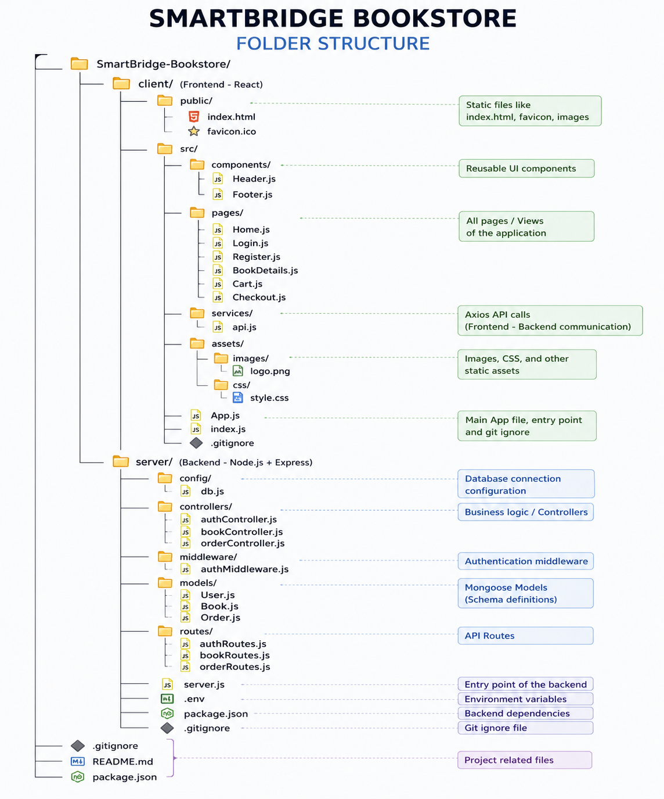

6. Running the Application

Start Backend: cd server npm start

Start Frontend: cd client npm start
The application will run at:
Frontend : http://localhost:3000
Backend : http://localhost:5000

7. API Documentation

Authentication APIs

Register User : POST /api/auth/register

Request Body
{
"name": "John",
"email": "john@example.com",
"password": "123456"
}
Response
{
"message": "User Registered Successfully"
}

Login User : POST /api/auth/login
Response {
"token": "JWT_TOKEN"
}

Book APIs :

Get All Books : GET /api/books
Get Book by ID: GET /api/books/:id
Add Book : POST /api/books
Update Book : PUT /api/books/:id
Delete Book : DELETE /api/books/:id

Order APIs :

Place Order : POST /api/orders
Get User Orders : GET /api/orders
.
8. Authentication :
- Authentication is implemented using JSON Web Tokens (JWT). Users must register and log in before accessing protected resources. After successful login, the server generates a JWT token which is stored on the client side. This token is included in the Authorization header for subsequent API requests. Protected routes are accessible only to authenticated users, while administrative operations are restricted to users with admin privileges..
- User Interface
  - The application provides a clean and user-friendly interface with responsive design..
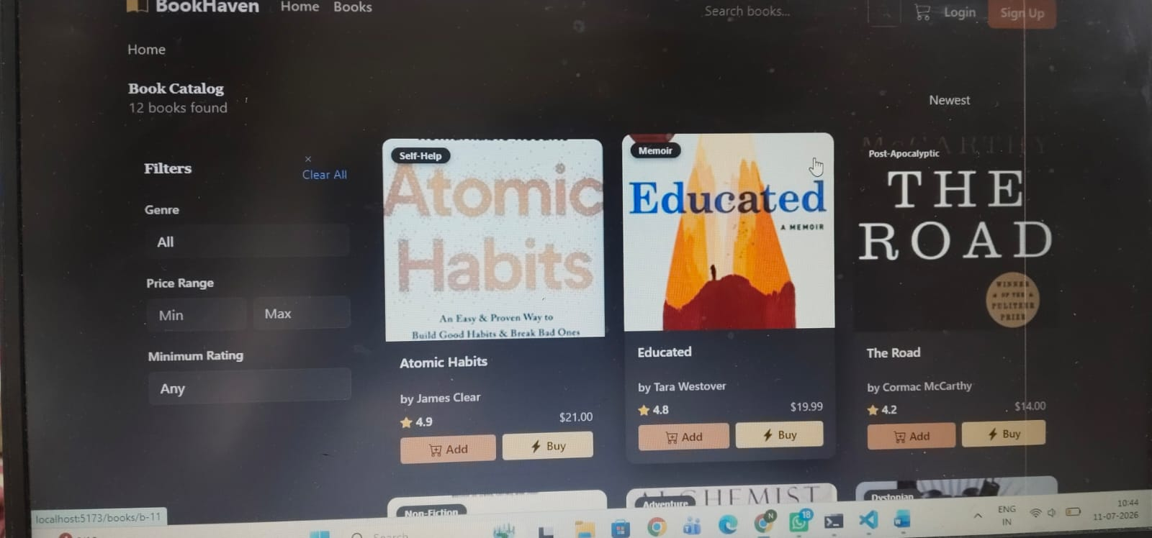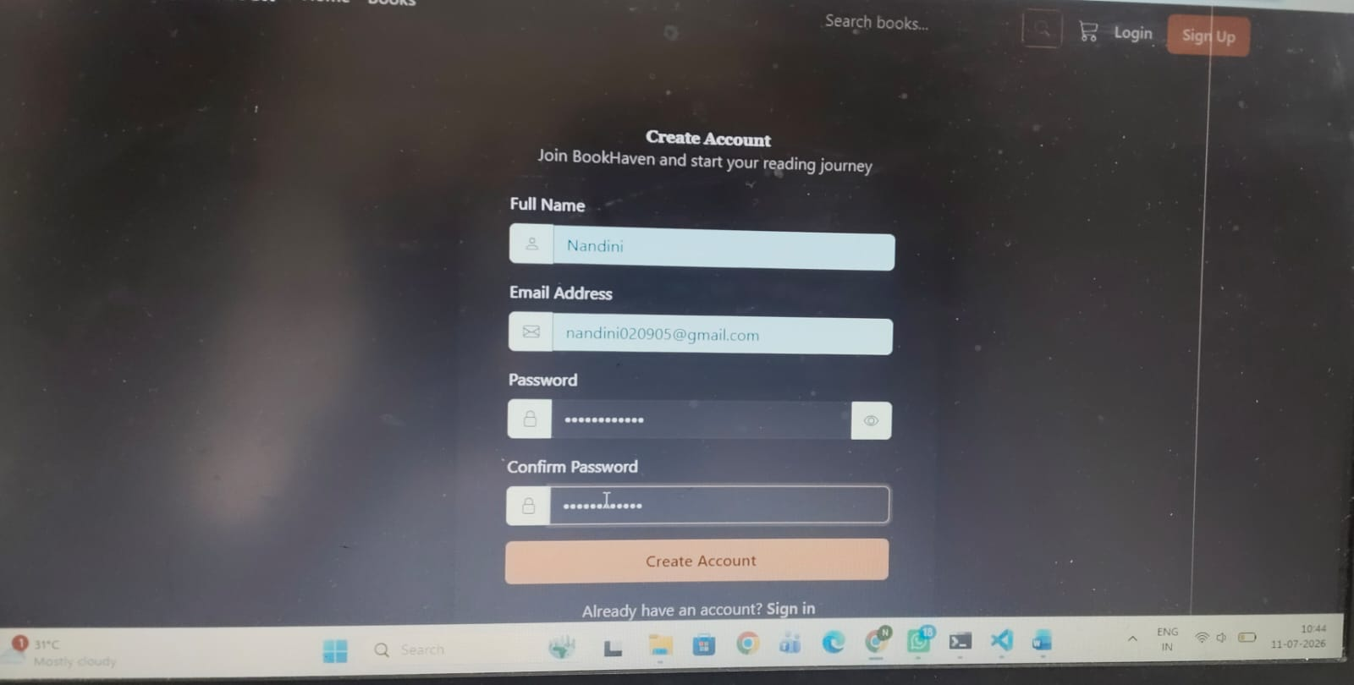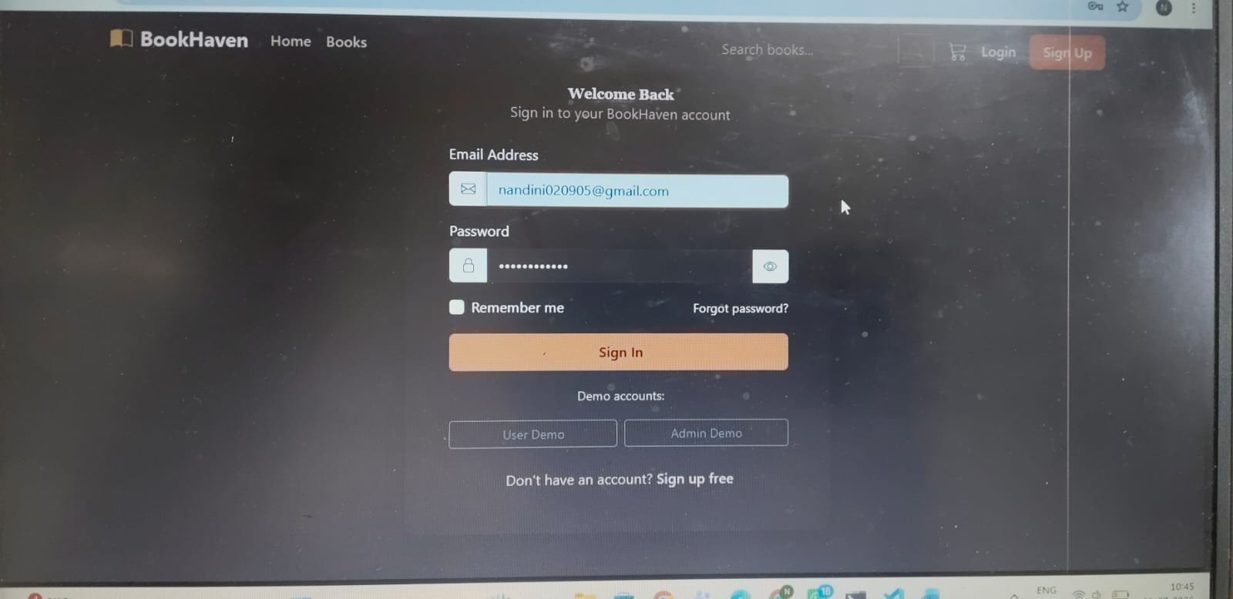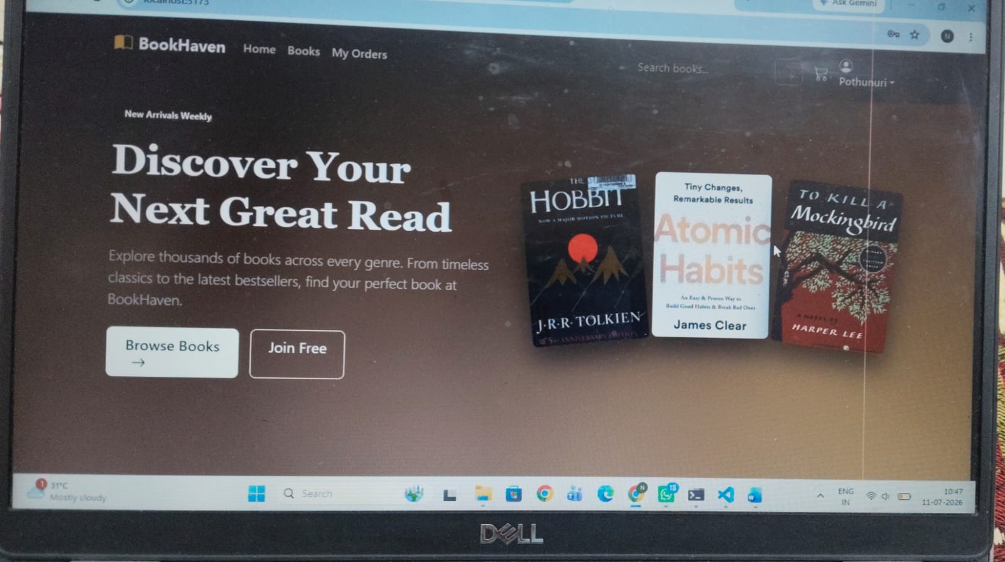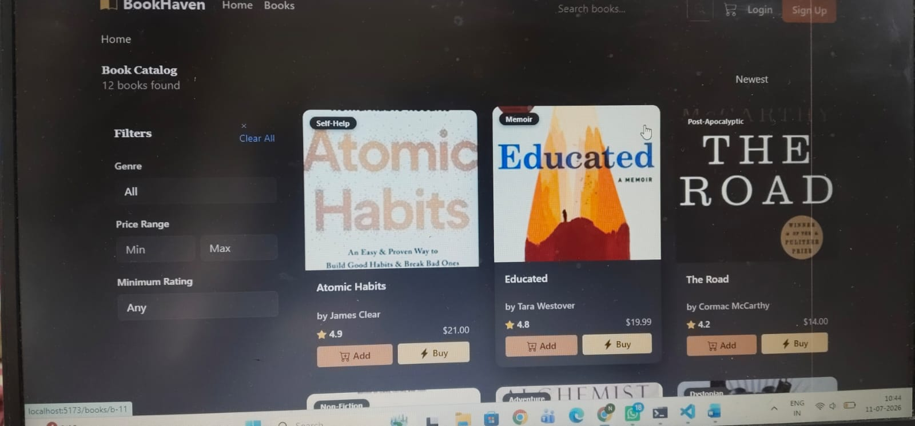

- Testing
The project was tested using the following methods:
- Functional Testing
- API Testing using Postman
- User Authentication Testing
- CRUD Operation Testing
- Responsive UI Testing
- Integration Testing
All major functionalities were verified to ensure the application works correctly without errors.
- Screenshots or Demo
  - Link demo to showcase the application http://localhost:5173/








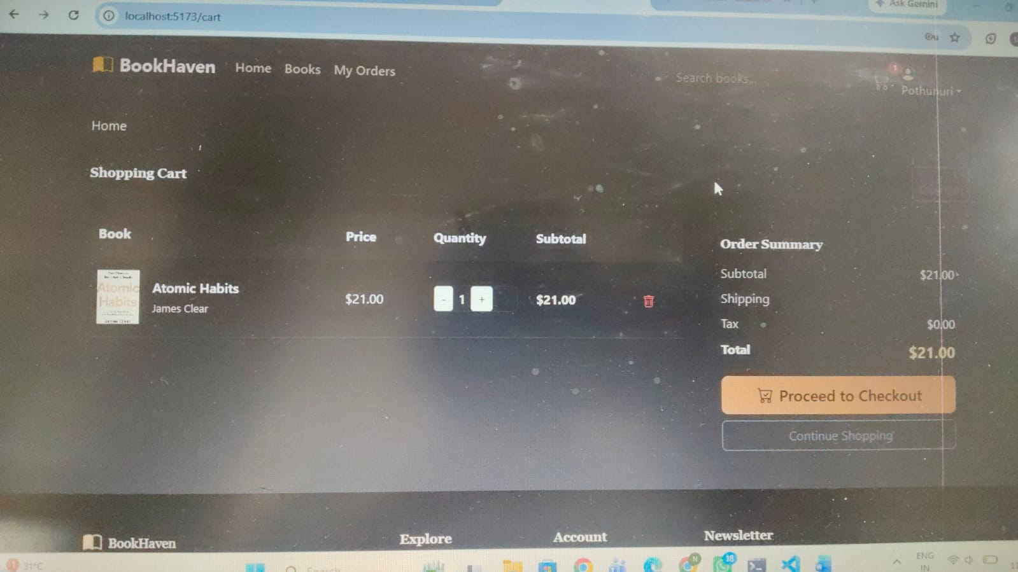

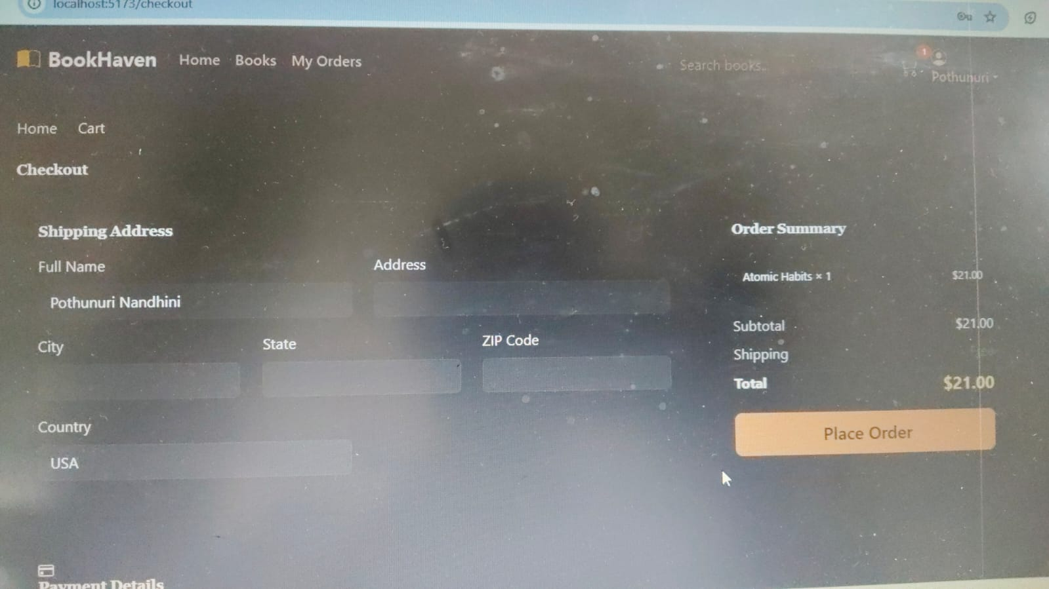

12 . Known Issues
- Payment gateway integration is currently not implemented.
- Email notifications are not available.
- Image upload functionality supports only basic file formats.
- Advanced filtering and recommendation features are limited.

13. Future Enhancements
- Online Payment Gateway Integration (Stripe/Razorpay)
- Wishlist Feature
- Book Reviews and Ratings
- AI-Based Book Recommendation System
- Order Tracking
- Email Notifications
- Inventory Management
- Multi-language Support
- Mobile Application Development
- Cloud Deployment using AWS or Azure

